Sorting Contest - Prog 3
CECS 325-01 System Programming with C++
Fall 2024
Due: Oct 15, 2024

Linux has a sort command. If you wanted to use the Linux sort command to sort all the items in a file called “numbers.dat”, you could use it like this:

$ sort numbers.dat ←This command treats the contents of the file like text
$ sort -n numbers.dat ← this command treats the contents of the file like numbers
$ sort -c numbers.dat ← this checks to see if the file is sorted

You could also sort the file like this:

$ cat numbers.dat | sort ←send output to stdout using cat, then pipe that to the sort command
$ more numbers.dat | sort ←send output to stdout using more, then pipe that to the sort command

You could sort the first or last 1000 numbers like this:

$ head -1000 numbers.dat | sort ← sort the first 1000 lines, send output to stdout (screen)
$ tail -1000 numbers.dat | sort ← sort the last 1000 lines, send output to stdout (screen)

Each of the above commands will display the sorted numbers (lines) on the screen. Instead of displaying the numbers, you could write them to a file called “sorted.out”

$ cat numbers.dat | sort > sorted.out ← redirect output to a file called “sorted.out”
$ sort -n numbers.dat > sorted.out

In this assignment you will generate a file that has 1 million random numbers between -100000 and +100000. Write these numbers to a file called “numbers.dat”. Then run this Linux command to see how long it takes to sort 1 million integers:

$ time sort -n numbers.dat > sorted.out

Here’s how fast it took on my computer:
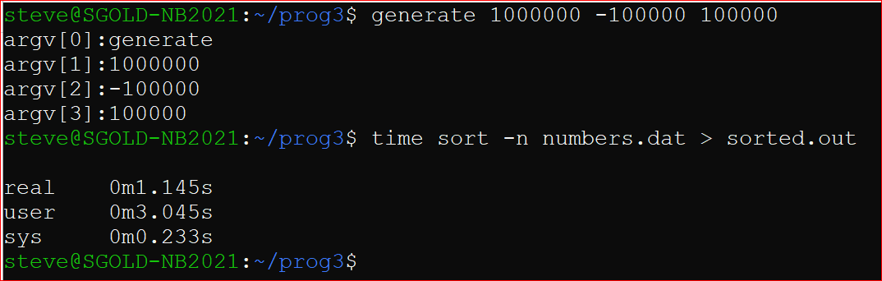

Your job is to write a sort program that uses the bubble sort.

This will take some time to sort and we don’t want to wait around for the results, so we will run the program in the background using the &.

You will run this shell file to test your program:

# This file is called sortrace.sh
# It must have execute privilege set to run
# run it as a background task like this: (see the 2 lines below)
#----------------------------------------------------------------------------------------------
# $ rm sortrace.log # start with fresh log file
# $ sortrace.sh >> sortrace.log & # this may take an hour
#----------------------------------------------------------------------------------------------
#
echo Generating 1000000 random numbers
sleep 1
generate 1000000 -100000 100000 # you have to write generate.cpp
sleep 1
echo Starting system sort
sleep 1
{ time sort -n numbers.dat > systemsort.out; } 2>> sortrace.log # this line is for Windows
{ time sort -n numbers.dat > systemsort.out; } 2>&1>> sortrace.log # modification for Mac
sleep 1
echo Starting mysort
sleep 1
{ time ./mysort numbers.dat mysort.out; } 2>> sortrace.log # this line is for Windows
{ time ./mysort numbers.dat sort.out; } 2>&1>> sortrace.log # modification for Mac computers
sleep 1
wc mysort.out
sort -c -n mysort.out 2>> sortrace.log # verify file is sorted

You must write the following programs
- generate.cpp
  - Purpose: generate a file called numbers.dat
  - Description: The numbers.dat file will have COUNT random numbers between MIN and MAX
  - Usage: generate COUNT MIN MAX
  - Example: generate 1000000 -100000 100000
  - This program accepts 3 command line arguments as shown above
  - If there are not 3 command line arguments, the program fails and prints error message
- mysort.cpp
  - Purpose: read numbers from input file, sort, write sorted numbers to output file
  - Description: Uses bubble sort function on an array of integers
  - Usage: mysort numbers.dat mysort.out
  - It accepts 2 command line arguments which is the input file and the output file name
  - It will accept up to 1 million numbers from the input file, but will run successfully with less

Requirements:
Use an array to store your numbers in mysort.cpp
You must have a function called bubble( int A[ ], int size)
The bubble function takes 2 parameters – the array and the number of items to sort.
The bubble function will be called from the main function
generate and mysort programs must work according to the above descriptions

What to submit:

- mysort.cpp
- generate.cpp
- sortrace.log
- sortrace.sh

Notice – Your requirement is to use the exact sortrace.sh file listed above which sorts 1,000,000 numbers. Mac users may need to make minor changes. However the graders will run your program with 10,000 numbers for efficiency so make sure it works with less than 1,000,000 numbers as described in the requirements.

Here is a possible screenshot of sortrace.log
